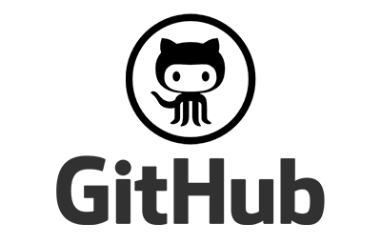

**GitHub: Repository Usage**

A basic tutorial for GitHub: Version Control, by Max Carter.

**Preliminary Steps:**

* Create an email-verified [GitHub account](https://github.com/join)
* Have a pre-installed IDE such as NetBeans, IntelliJ or Eclipse (Tutorial uses NetBeans)

**Creating a Repository to Upload Code**

**Step 1 - Create a Repository:**

A repository can be created [here](https://github.com/new). Fill in the information, here is an example of what it should look like.

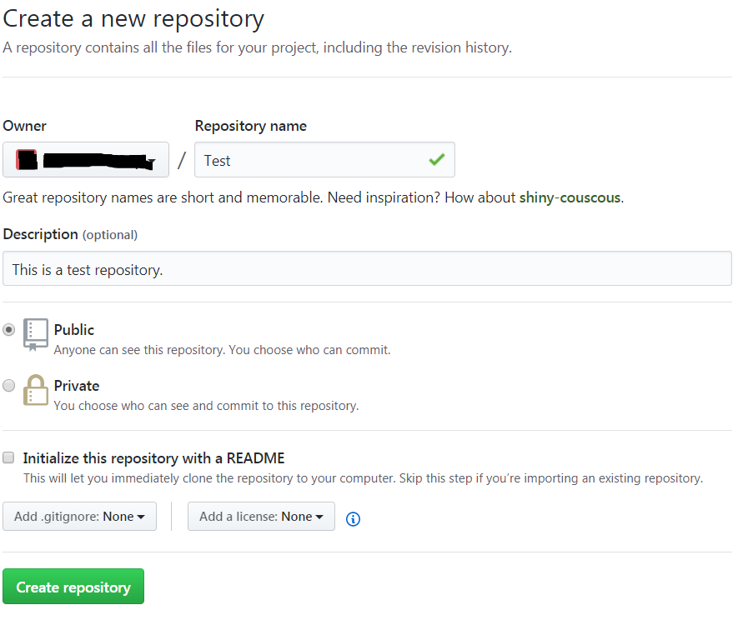

You need to enter the name, a description, and state whether it is public or private. Public means anyone can find and use your code, private means only certain users can see your code, however this costs money every month. A license is not needed. Click the create repository button when you filled in the information, this is what it should look like:

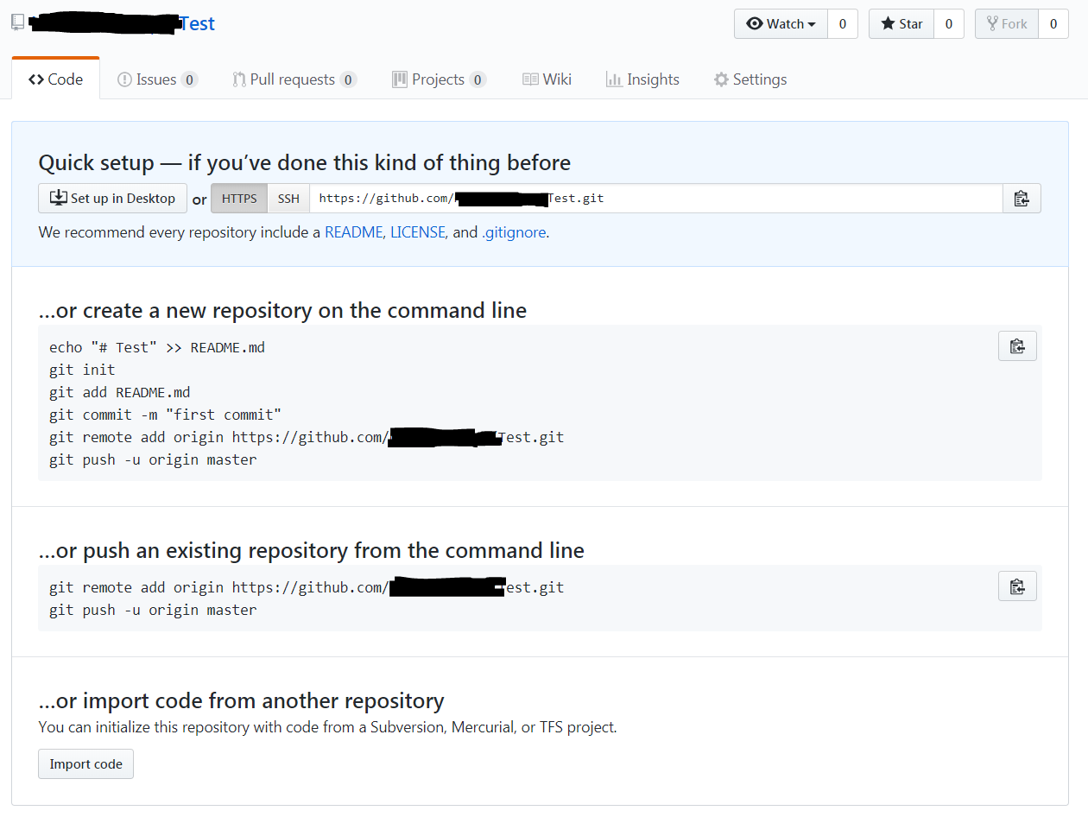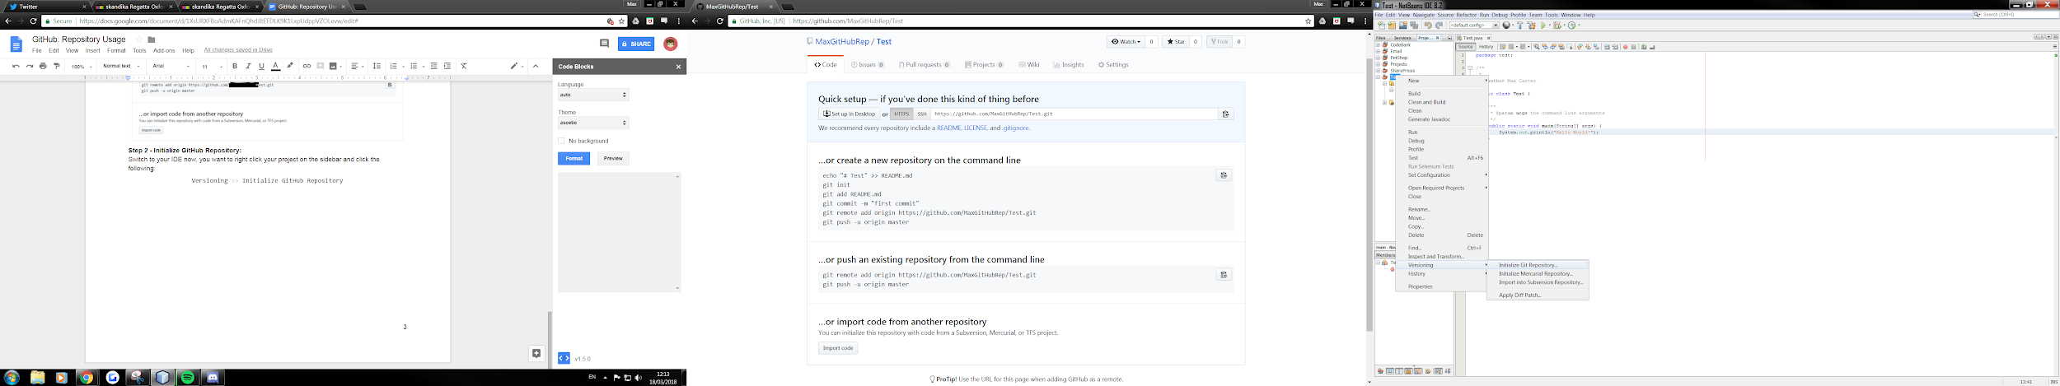

**Step 2 - Initialize GitHub Repository:**

Switch to your IDE now, you want to right click your project on the sidebar and click the following:

|  |
| --- |
| Versioning >> Initialize GitHub Repository |

A box will appear prompting you for a file path, press OK.

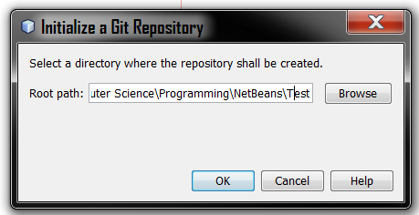

**Step 3 - Committing Code:**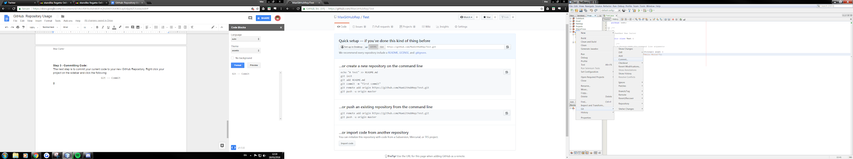

The next step is to commit your current code to your new GitHub Repository. Right click your project on the sidebar and click the following:

|  |
| --- |
| Git >> Commit |

After clicking this, a menu box should appear like this:

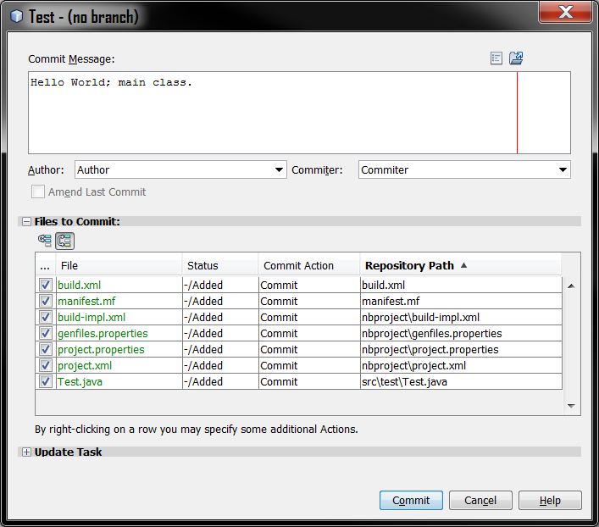

A series of text boxes will appear, here’s what you should write in them:

*Commit Message:*

* A short description of what your code does, or any changes you have made.

*Author:*

* You want to write down your name and your email address. For Example:

|  |
| --- |
| Author <example@gmail.com> |

*Committer:*

* You can write down the same in here as you did with the Author text field.

Once you have filled out the boxes, you can select which files you want to commit to GitHub, the tick boxes next to the file names in the above diagram indicate the files you are commiting.

Once you have decided what files you will commit, press the commit button at the bottom.

**Step 4 - Pushing Code:**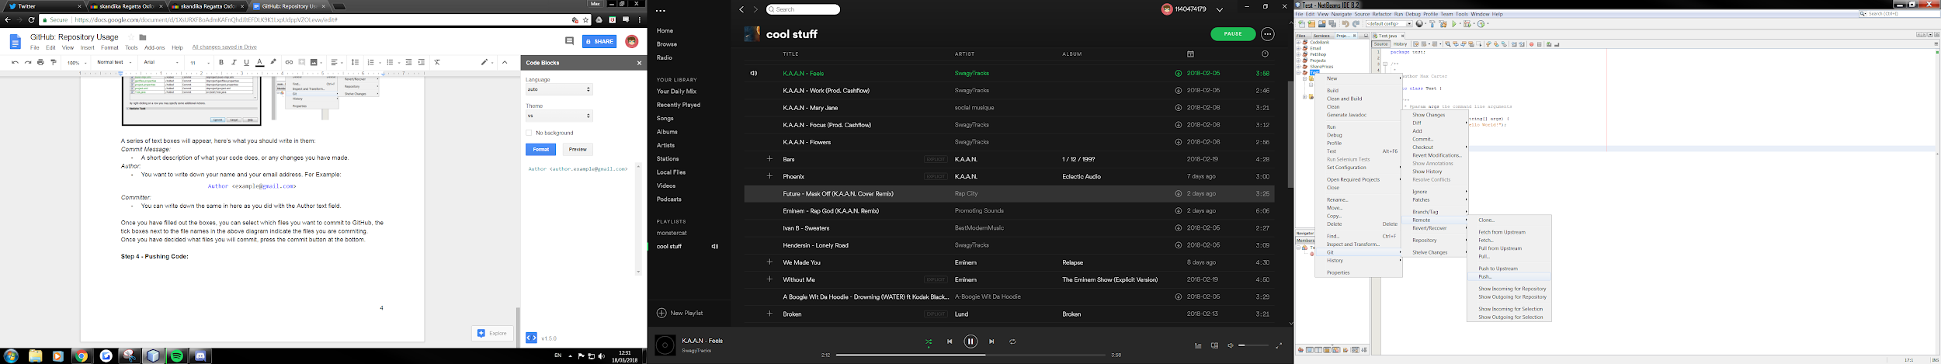

Once you have commited your code, you now need to push that code to your repository. Right click your project on the sidebar and click the following:

|  |
| --- |
| Git >> Remote >> Push |

A menu will appear with several text boxes like this:

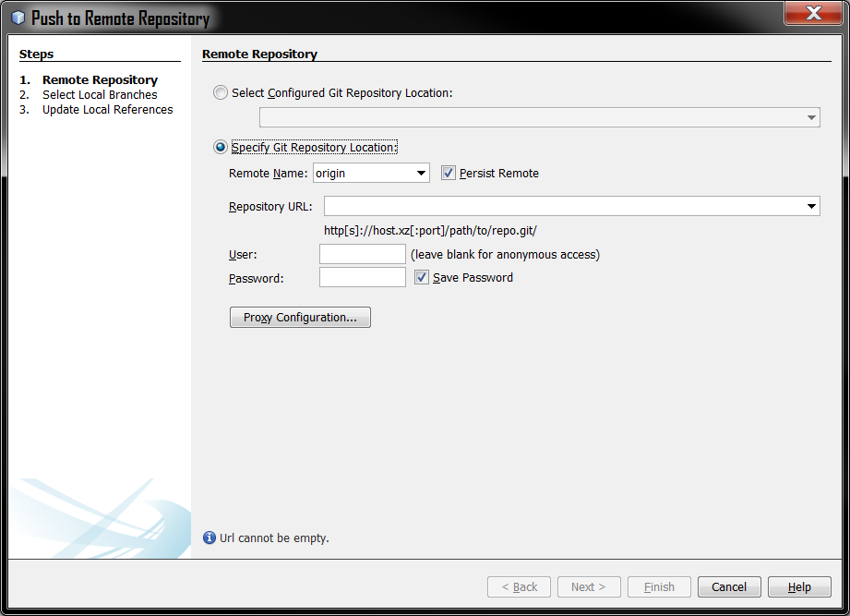

If we go back to GitHub, we can obtain a link that will allow us to connect to our repository:

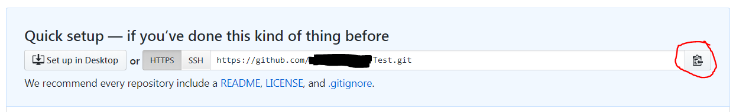

Copy this link (You can click the red circled button) and you want to paste it into the *Repository URL* text box as followed:



The next step is to enter your username and password as shown:



Once you have filled in those fields, another box will appear like this:

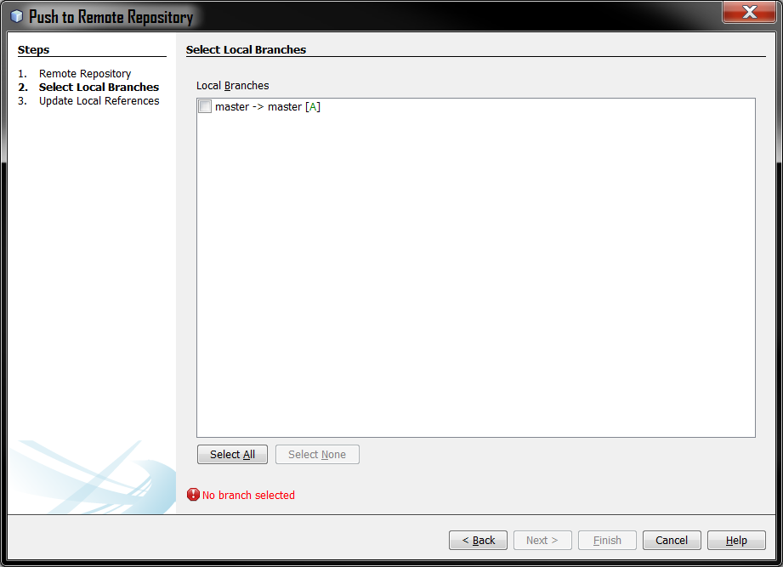

You want to select the top option, this will cause the red error to go away, and you can press Next.

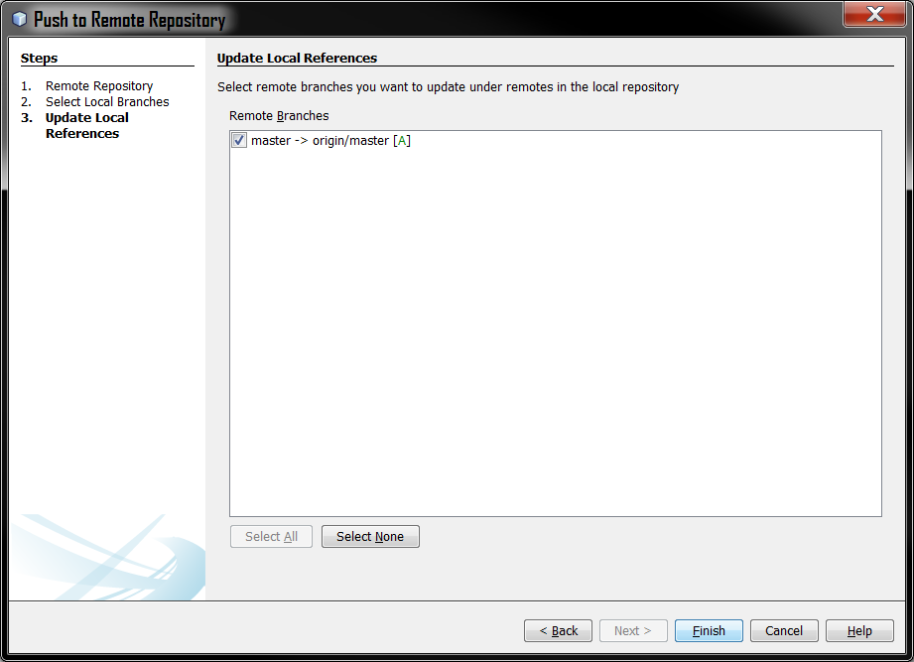

A new box will appear, you can press *Finish* now.

The first time you push code, a message will appear like this:

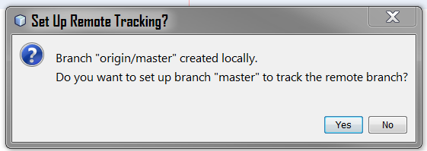

Press *Yes* and then your code will be pushed.

Now if you refresh the GitHub page, it should look something like this:

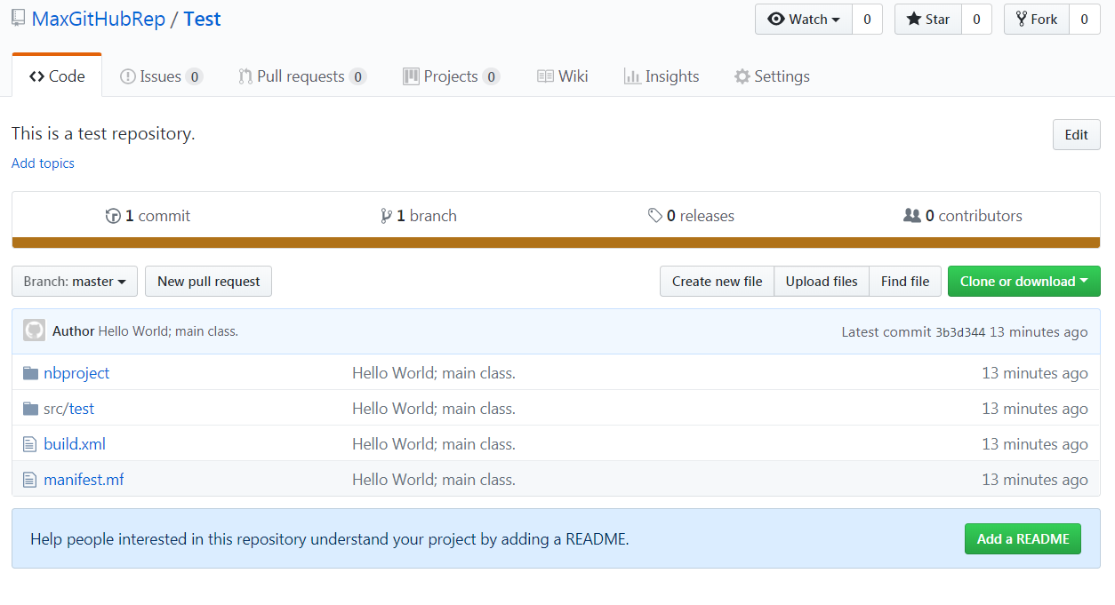

And there you have it, you have just pushed your code to GitHub!

**Pulling Code From a Repository**

Once you have set up your GitHub repository, you will also want to pull your code. This bit comes in two parts:

1. Cloning a Repository.
2. Pulling your code.

If you push a project to GitHub, and you want to access it somewhere else (EG: Another computer), then you need to clone the repository first. If you already have a pre-existing copy of the code on your current computer, then you can skip straight to the next step.

**Step 1 - Cloning a Repository:**

Go back to your GitHub Repository online, and click the *Clone or download* button like so:

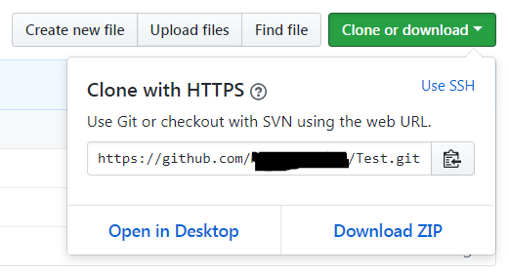

You want to copy that link in the text box.

Go back into your IDE, you want to execute the following:

|  |
| --- |
| Team >> Git >> Clone... |

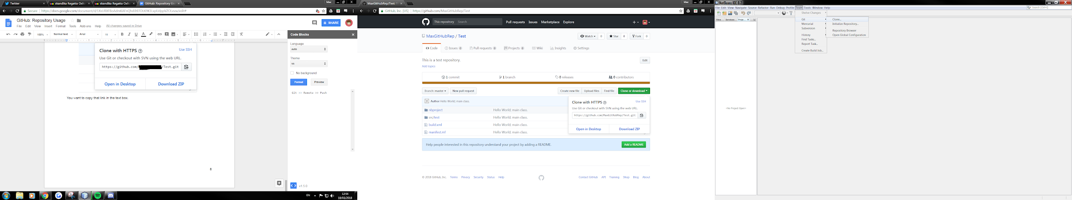

A menu like this will then appear:

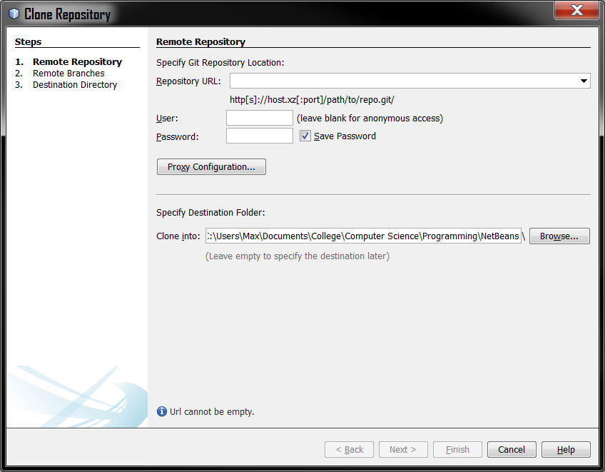

Paste the URL into the *Repository URL* text box, and fill in your username and password for GitHub, then press *Next*.

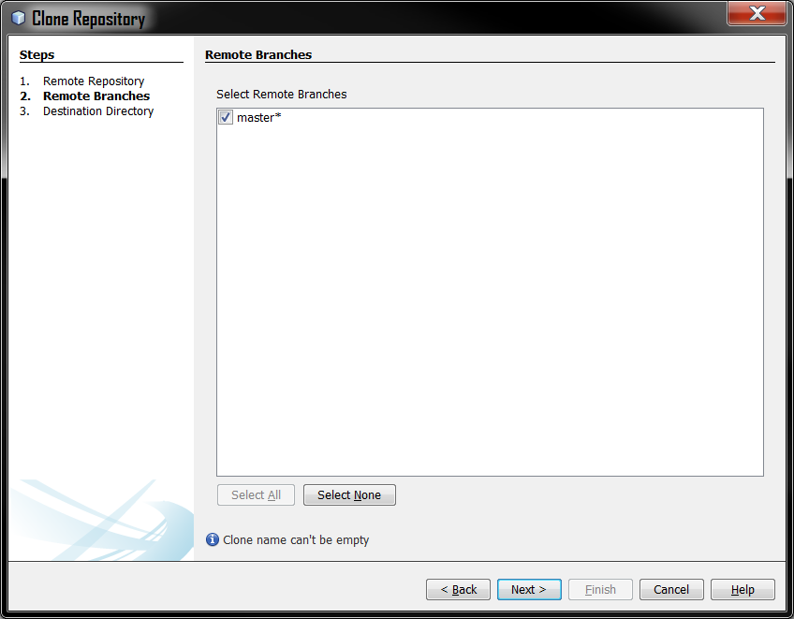

The final menu will appear, in which you can press *Finish*.

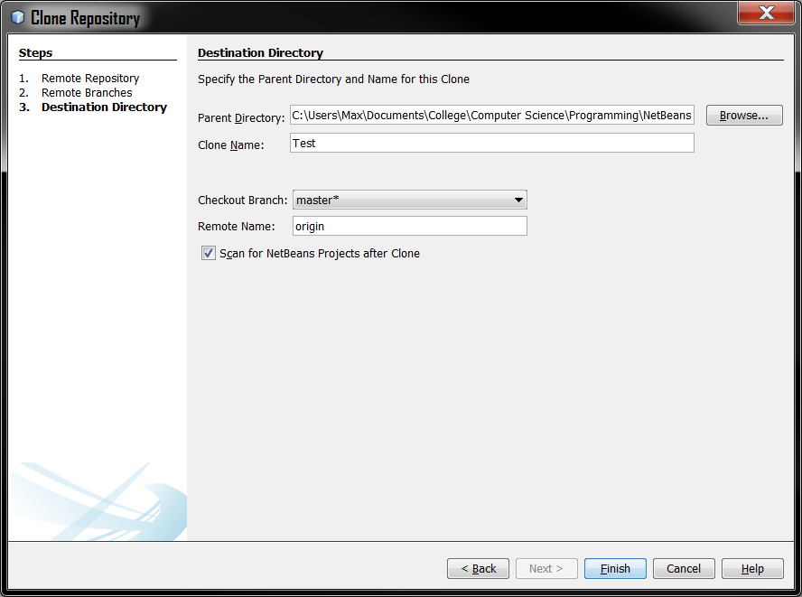

Once you click finish, you should see your project on the sidebar all ready for you!

Alternatively, if you already have a project saved onto your computer, and want to pull the new updated code from GitHub, follow these instructions:

**Step 1 - Pulling Code:**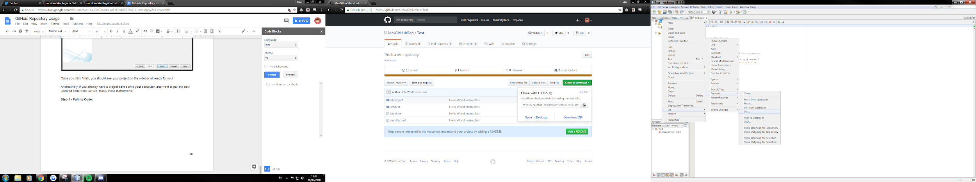

When you pull code from GitHub, it is assumed that you already have a copy of the repository on your computer.

Right click your project on the sidebar and click the following:

|  |
| --- |
| Git >> Remote >> Pull |

A menu should appear like this:

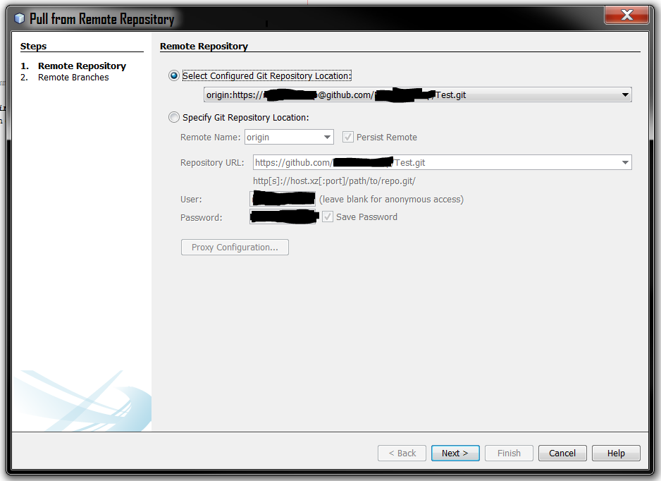

Click *Next*.

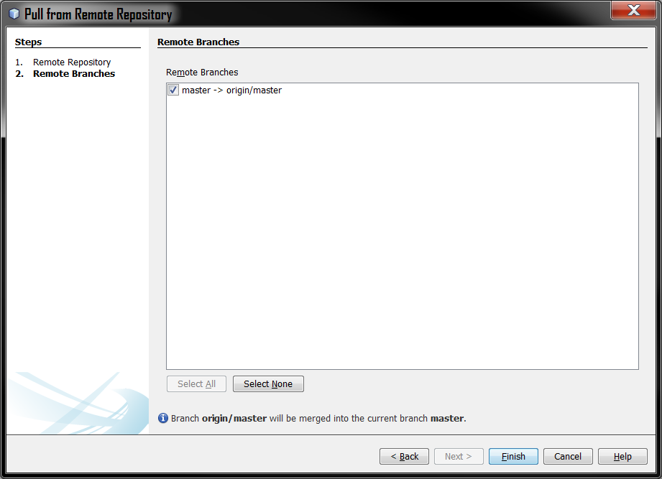

Click *Finish*.

Now your code will be pulled from your existing repository!